http://www.displaycalibrations.com/images/logo.png

http://www.displaycalibrations.com/images/menu_logo/Newsletter.png

**eeColor 3D LUT Box Special Offer**

There available units of [eeColor 3D LUT Box](http://www.displaycalibrations.com/eecolor_order.html), the most powerful 3D LUT Box for SDR (up to 1080p60 36-bit colordepth) with the largest 3D LUT Cube size (65-Point Cube, 274625 Color Points) available, as you can see to following list of all the available 3D LUT solutions of the global market: <http://www.displaycalibrations.com/lut_boxes_comparisons.html>

Performing display/projector characterization with eeColor 3D LUT Box, you can get the best possible picture for SDR (up to 1080p60 input/output) from any TV/projector of any price range.

eeColor is the only 3D LUT Box which can be used with free open source software (DisplayCAL/ArgyllCMS) so this keeps the total cost very low (you will need a colorimeter only and a cheap HDMI pattern generator; ChromeCast or FireStick...or use a tested HDMI notebook output), no need to ordered a paid software solution, but you can use eeColor 3D LUT with LightSpace Full CMS / HCC / HCL / HTL / HTP / CAL / LTE / PRO / XTP, CalMAN 5 Enthusiast / Professional / Studio / Ultimate from paid software solutions. All other 3D LUT Boxes of the HT market require a paid software solution.

The displays/projectors are coming with some calibration controls which give the capability to calibrate it's Grayscale/Gamma/Color Gamut.

About Grayscale they will 10 or 20-Point RGB Balance controls to be able to calibrate Grayscale/Gamma and 1-point per primary/secondary colors for gamut to calibrate 6 colors.

Performing the classic calibration using the available calibration controls, when you are moving away from the calibrated points and measuring other luminance or saturation levels, the errors are will be increased, so the more points (of different luminance/saturation levels) you measure the more errors you will locate. Classic charts or limited points being measuring usually for verification don't report these issues.

Generally fixing only grayscale issues doesn't guarantee an accurate picture, you get only some good looking Grayscale charts with low dE, the real performance can still have a lot of errors because you are correcting only a few points, away from skin tones or memory colors correction, most of the movies are using mid-low saturation/luminance range colors if you analyze movies data's; most of the colors have mid-low levels, away from the edge of the gamut (100% Saturation / 100% Luminance); the colors which commonly calibrated using display internal calibration controls and default calibration software workflows.

Using 3D LUT you calibrate many different levels or saturation/hue/luminance, so your performance will be reference at any color, in 8-bit systems, the allocation of 17 nodes per component (17-Point Cube) proves that is best trade-off between display/meter/processor hardware / measuring time / display stability and overall quality, that's why that size is commonly used at professional industry.

The most important is the total volumetric accuracy for the best final results, consumer displays don’t have so linear tracking to its all areas, so a large cube with a profiling sequence that 17-Point Cube (4.913 Color Points) grid-based with equal spaced RGB values will cover all potential colors equally and give the most accurate correction.

With manual calibration using internal controls you have to take multiple adjustments of the available calibration controls, but usually one change at one area is affecting nearby areas so at the end you will spend some hours only to do a 10-Point Grayscale calibration, until to get some good-looking charts.

This is a RGB 3D Cube presentation; you see what points represent the 10-Point Grayscale calibration you perform using the internal calibration controls of a display/projector:

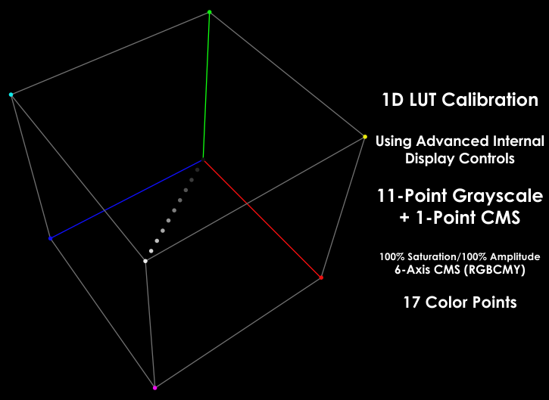

The average Caucasian skin tone resides well away from any grey scale, or primary color, this is why the ColorChecker patches is a good choice of measurement run (after Saturation sweep run) because its including skin tones, grass, sky, etc.; which are memory colors.

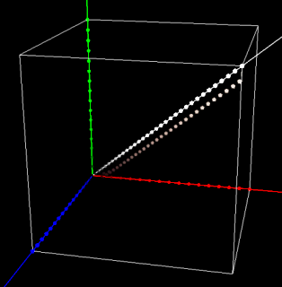

With 3D LUT you will have to do only basic setup from your internal calibration controls, contrast/brightness/sharpness, select the native gamut option and pre-calibrate only 100% White....and then let the other thousand color points to be measured by (LightSpace/CalMAN/DisplayCAL/ArgyllCMS) and from the thousand points it will be measured automatically, the 3D LUT correction will be generated for 65-Point Cube (274.625 Color Points) for eeColor and global correction will be stored to eeColor’s memory.

This operation takes about 2-3 hours (or set a number or points you want...to take less time....but the more points the software will measure....the more details will know about your display/projector capabilities, so about 3500-5000 points are the ideal number for most display/projectors.

Then you will upload the 3D LUT correction file to eeColor 3D LUT Box; after that you will be able to take post-verification measurements.

Here is the 3D Cube presentation of RGB space using 3D LUT correction with 17 / 21-Point cube size for example:

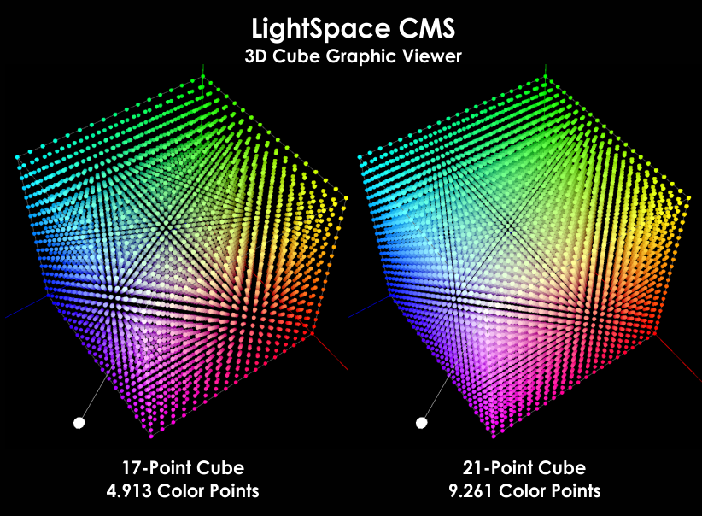

Ever Dolby Monitor which designed to be reference needs 3D LUT profiling to meet the tight tolerance in color errors that required for critical color reproduction for movie grading in post-production facilities.

For example Dolby Monitor PRM-4200/4220 has 2x 65-Point 3D LUT Tables slots, same size like eeColor 3D LUT Box which has 6 memory slots.

3D LUT is the best solution for reference quality SDR pictures, because REC.709 (Blu-Ray) is a colorspace which nearly all the displays/projectors are covering 100% calibrated and cover obviously blu-ray's mastered luminance levels also (100-120nits) so for SDR (displays) or 48 nits for projectors, it’s the ultimate solution to transform any display/projector to a reference level.

eeColor is a small device with HDMI In-Out which you connect it between your player and your TV/projector.

Inside to eeColor there 6 memory slots to upload correction for 274625 color points.

For the measurements, you need to use a pattern generator or your notebook output.

From the calibration software available for 3D LUT, it's the DisplayCAL (free open source) and from the paid software solutions it’s the CalMAN Enthousiast or LightSpace HTL the minimum required license levels to work with eeColor.

For patch generation you can use the Google Chromacast (which DisplayCAL support) or Amazon Firestick (which LightSpace or CalMAN support) to be able to generate thousand color patches required during the 3D LUT process.

If you see that your notebook output is good, then you can use it for patch generation and don't need to buy Chromecast or Firestick.

To see if your notebook output has perfect video output, you have to measure the Grayscale and 4-Point Saturation using a known reference calibration disk (like Ted’s LightSpace CMS calibration Disk) patterns and then do the same using your notebook HDMI output as extended desktop using HCFR/CalMAN software patch generator the same grayscale/saturation patterns, of you can compare LightSpace Quick Profile patches which are available to Ted’s Disk.

Compare the 2 reports and if you see that all are fine then your notebook output can be used as patch generation.

For 3D LUT, the software will measure 1000-5000 (or more) automatically and use advanced maths/interpollation to generate the correction for thousand colors points, so you will have perfect skintones and perfect colors.

Because the Gamma of SDR movies mastered its variable from year-to-year, it's unknown what gamma value each studio has used, currently most of the studios are using 2.4, before some years it was 2.35 (per EBU...now EBU has changed it to 2.4), older movies were 2.2....for that reason having one gamma option (using internal calibration controls) it's not guarantee to you good performance to all the movies you will watch.

When you do 3D LUT for SDR with eeColor 3D LUT Box, you can generate different 3D LUT tables with various gamma options to 3-4 slots (using the same display measured data from one measurement run...no need to re-measure for each target gamma, if your software support this), to swap real-time and see how it's affecting you picture while you playback a movie and select the one that you are satisfied most...since we are don't know what gamma each studio has used each SDR movie.

Check here some reports from 3D LUT using LightSpace for 3D LUT correction generation and CalMAN as verification only:

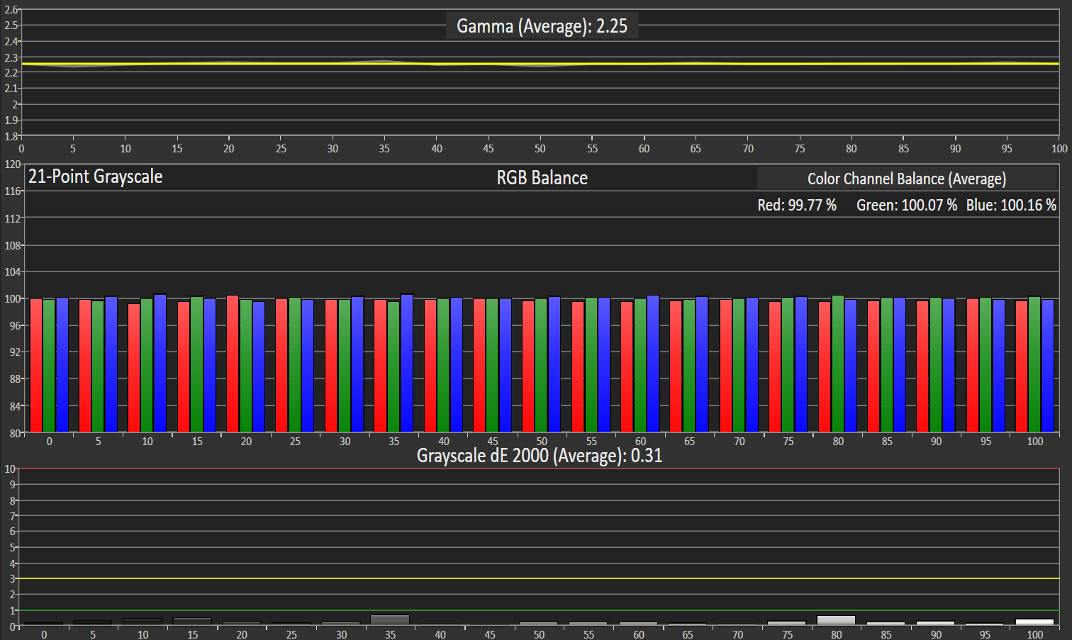

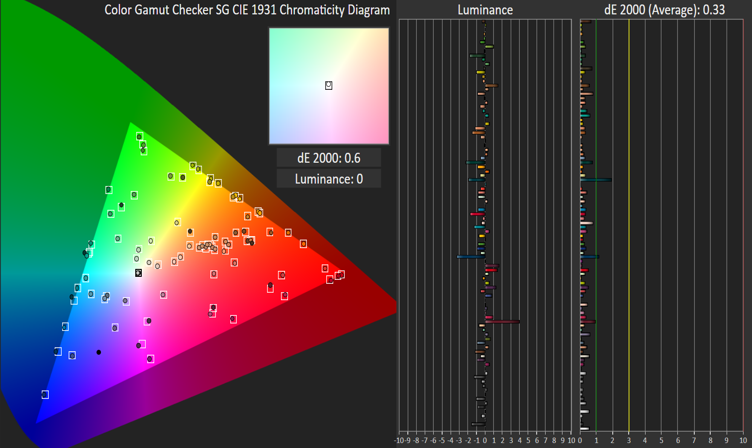

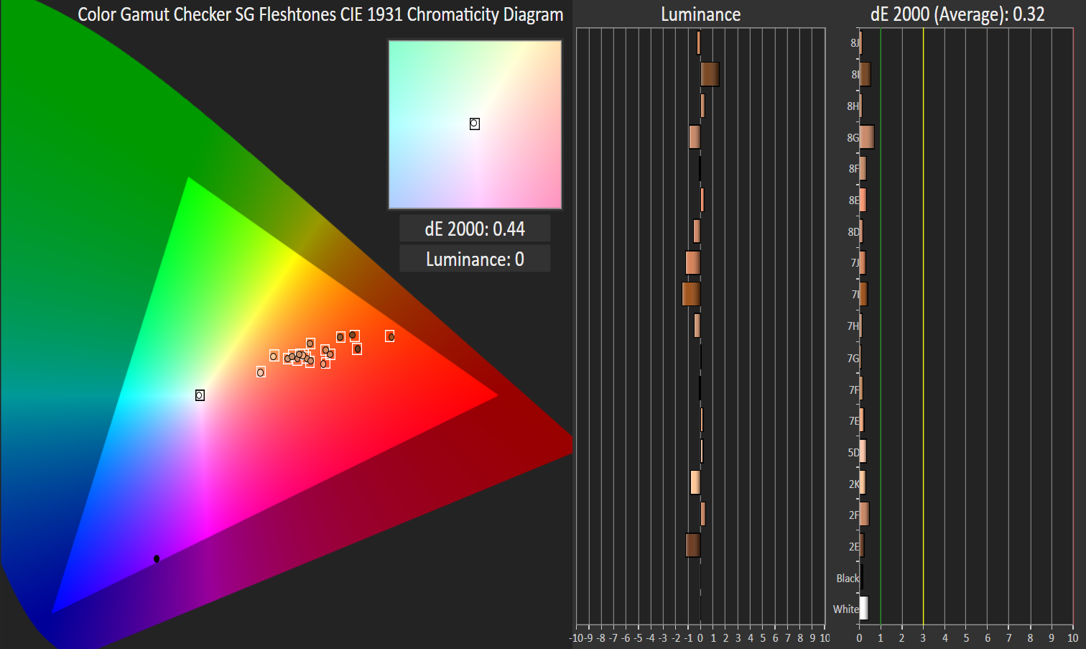

So the 3D LUT software will upload (or it will be required to do a manual upload) to your eeColor the 3D LUT correction, it's not required a parametric/detailed pre-calibration of the display using the available internal calibration controls before starting the 3D LUT; It's only required to select the largest gamut (native gamut) of the display and pre-calibrate only 100% White using the RGB-High/Gain controls, after that you start the 3D LUT measurements.

When you will measure for 3D LUT, you will connect the pattern generator to eeColor's HDMI input and when you finish all the measurements and take post-calibration verification measurements also then you will connect your player to the eeColor's input.

This is a general but detailed idea about how 3D LUT display characterization with eeColor 3D LUT Box can be performed.

If you need any other details please let me know.

**Ted Aspiotis**

[www.displaycalibrations.com](http://www.displaycalibrations.com)

Athens, Greece